Civil War Legislation Packet
Source: 13th Amendment to the United States Constitution
AMENDMENT XIII
Section 1.
Neither slavery nor involuntary servitude, except as a punishment for crime whereof the party shall have been duly convicted, shall exist within the United States, or any place subject to their jurisdiction.
Section 2.
Congress shall have power to enforce this article by appropriate legislation.
Historical Context
Intended Audience
Purpose
Point of View
Outside Information
Homestead Act Reading (History.com & Discovery Education)
On May 20, 1862, Abraham Lincoln signed the Homestead Act into law. Under the terms of the act, anyone who was older than 21 or was the head of a household could file a claim for a land grant. The law required that applicants had never taken up arms against the United States. These applicants, called homesteaders, had to work the land (an area of 160 acres) and live on it for five years. They were able to buy land for $1.25 an acre. After five years, the homesteader could pay a registration fee and apply for the deed to the land.
The Homestead Act was intended to alleviate poverty by allowing people to move west and take advantage of unsettled land. In reality, much of the land went to railroad developers and speculators rather than families. Also, much of the land was ill suited to farming and families found it difficult to make a living on it.
The Homestead Act opened up settlement in the western United States, allowing any American, including freed slaves, to put in a claim for up to 160 free acres of federal land. By the end of the Civil War, 15,000 homestead claims had been established, and more followed in the postwar years. Eventually, 1.6 million individual claims would be approved; nearly ten percent of all government held property for a total of 420,000 square miles of territory.
The Homestead Act (May 20, 1862) set in motion a program of public land grants to small farmers. After the southern states had seceded, homestead legislation was high on the Republican agenda. The Homestead Act of 1862 provided that any adult citizen (or person intending to become a citizen) who headed a family could qualify for a grant of 160 acres of public land by paying a small registration fee and living on the land continuously for five years. If the settler was willing to pay $1.25 an acre, he could obtain the land after only six months’ residence.
But the law did not provide the new beginning for urban slum dwellers that some had hoped; few such families had the resources to start farming, even on free land. The grants did give new opportunities to many impoverished farmers from the East and Midwest, but much of the land granted under the Homestead Act fell quickly into the hands of speculators.
Source: The Homestead Act of 1862
Be it enacted by the Senate and House of Representatives of the United States of America in Congress assembled, That any person who is the head of a family, or who has arrived at the age of twenty-one years, and is a citizen of the United States, or who shall have filed his declaration of intention to become such, as required by the naturalization laws of the United States, and who has never borne arms against the United States Government or given aid and comfort to its enemies, shall, from and after the first January, eighteen hundred and sixty-three, be entitled to enter one quarter section or a less quantity of unappropriated public lands, upon which said person may have filed a preemption claim, or which may, at the time the application is made, be subject to preemption at one dollar and twenty-five cents, or less, per acre; or eighty acres or less of such unappropriated lands, at two dollars and fifty cents per acre, to be located in a body, in conformity to the legal subdivisions of the public lands, and after the same shall have been surveyed: Provided, That any person owning and residing on land may, under the provisions of this act, enter other land lying contiguous to his or her said land, which shall not, with the land so already owned and occupied, exceed in the aggregate one hundred and sixty acres.
Historical Context
Intended Audience
Purpose
Point of View
Outside Information

Source: The Morrill Act (1862)
“by each State which may take and claim the benefit of this act, to the endowment, support, and maintenance of at least one college where the leading object shall be, without excluding other scientific and classical studies, and including military tactics, to teach such branches of learning as are related to agriculture and the mechanic arts, in such manner as the legislatures of the States may respectively prescribe, in order to promote the liberal and practical education of the industrial classes in the several pursuits and professions in life.”
Historical Context
Intended Audience
Purpose
Point of View
Outside Information

Historical Context
Intended Audience
Purpose
Point of View
Outside Information
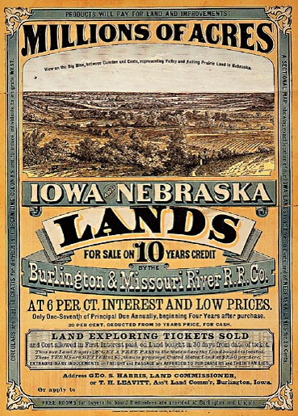
Source: The Pacific Railway Act, 1862
“. . . Sec.2. And be it further enacted, That the right of way through the public lands be, and the same is hereby, granted to said company [The Union Pacific Railroad Company] for the construction of said railroad and telegraph line; and the right, power, and authority is hereby given to said company to take from the public lands adjacent to the line of said road, earth, stone, timber, and other materials for the construction thereof; said right of way is granted to said railroad to the extent of two hundred feet in width on each side of said railroad where it may pass over the public lands, including all necessary grounds for stations, buildings, workshops, and depots, machine shops, switches, side tracks, turn-tables, and water stations. The United States shall extinguish as rapidly as may be, the Indian titles to all lands falling under the operation of this act and required for the said right of way and grants hereinafter made.
Sec.3. And be it further enacted, That there be, and is hereby, granted to the said company, for the purpose of aiding in the construction of said railroad and telegraph line, and to secure the safe and speedy transportation of the mails, troops, munitions of war, and public stores thereon…”

Historical Context
Intended Audience
Purpose
Point of View
Outside Information

