Monroe Doctrine Packet
The Monroe Doctrine
On December 6, 1823, President James Monroe gave a State of the Union address. Part of the speech became known as the Monroe Doctrine. The “allied powers” Monroe refers to are Russia, Prussia, Austria, and France. Earlier in the year, these European monarchies had crushed a revolution in Spain and restored the Spanish king to his throne. They were threatening to help Spain regain its Latin American colonies. This document has become the center of US foreign policy, which emphasizes non-interference in European affairs and a defense of neutral rights.

[T]he occasion has been judged proper for asserting, as a principle in which the rights and interests of the United States are involved, that the American continents, by the free and independent condition which they have assumed and maintain, are henceforth not to be considered as subjects for future colonization by any European powers. . . . It was stated at the commencement of the last session that great effort was then making in Spain and Portugal to improve the condition of the people of those countries and that it appeared to be conducted with extraordinary moderation. It need scarcely be remarked that the result has been so far very different from what was then anticipated. . . . The citizens of the United States cherish sentiments the most friendly in favor of the liberty and happiness of their fellowmen on that side of the Atlantic. In the wars of the European powers in matters relating to themselves we have never taken any part, nor does it comport₁ with our policy so to do. It is only when our rights are invaded or seriously menaced₂ that we resent injuries or make preparation for our defense.

With the movements in this hemisphere we are of necessity more immediately connected, and by causes which must be obvious to all enlightened and impartial observers. The political system of the allied powers is essentially different in this respect from that of America. This difference proceeds from that which exists in their respective governments; and to the defense of our own, which has been achieved by the loss of so much blood and treasure, and matured by the wisdom of their most enlightened citizens, and under which we have enjoyed unexampled felicity,₃ this whole nation is devoted. We owe it, therefore, to candor₄ and to the amicable₅ relations existing between the United States and those powers to declare that we should consider any attempt on their part to extend their system to any portion of this hemisphere as dangerous to our peace and safety.

With the existing colonies or dependencies of any European power we have not interfered and shall not interfere. But with the governments who have declared their independence and maintained it, and whose independence we have, on great consideration and on just principles, acknowledged, we could not view any interposition₆ for the purpose of oppressing them, or controlling in any other manner their destiny, by any European power in any other light than as the manifestation of an unfriendly disposition toward the United States. In the war between those new governments and Spain we declared our neutrality at the time of their recognition, and to this we have adhered and shall continue to adhere, provided no change shall occur which, in the judgment of the competent authorities of this government, shall make a corresponding change on the part of the United States indispensable to their security.

The late events in Spain and Portugal show that Europe is still unsettled. Of this important fact no stronger proof can be adduced than that the allied powers should have thought it proper, on any principle satisfactory to themselves, to have interposed by force in the internal concerns of Spain. To what extent such interposition may be carried, on the same principle, is a question in which all independent powers whose governments differ from theirs are interested, even those most remote, and surely none more so than the United States.

1. comport: agree with.
2. menaced: threatened.
3. unexampled felicity: the greatest happiness.
4. candor: honesty.
5. amicable: friendly.
6. interposition: interference.

Monroe, James. (1823) The Monroe Doctrine. http://www.ushistory.org/documents/monroe.htm. (27 March 2009).

- According to the introduction, what are the two important parts of the Monroe Doctrine?
- Why might Monroe refer to the United States as “the American continents?”
- What is Monroe’s opinion regarding the “great effort” to improve people’s lives in Spain and Portugal?
- What position does Monroe state that the US will maintain in European wars?
- Who does Monroe refer to when he “declares” that any “attempt” will be seen as “dangerous?”
- What reason does Monroe give for United States concern over events in Spain and Portugal?
- Why might the US want no more European colonies in the Americas, particularly in Latin America?
- For decades, the US lacked the military power to enforce the Monroe Doctrine – they depended upon the British navy to keep other powers out. Why, then, did the US proclaim the Monroe Doctrine?

United States Textbook (Document A)
Source: Our United States: A History for Upper Grammar Grades and Junior High School. William Backus Guitteau, 1930

Clearly the time had come for the United States to take a decided stand on the question of European interference in American Affairs. It was proposed, that Great Britain and the United States should unite in declaration that we would not permit an attack upon the new republics [of Latin America]. But John Quincy Adams, our Secretary of State, advised President Monroe that the United States should act alone on what was clearly an American question. The President decided to adopt this course, and...to Congress on December 2nd, 1823, announces to the world the famous Monroe Doctrine:

- As heretofore, the United States “will not interfere in the international concerns of any European power.
- European governments must not meddle in American affairs or attempt the conquest of young republics (democracies)
- European nations must not attempt to set up any new colonies on the American continent.

Thus the Monroe Doctrine is really a declaration of home rule - America for the Americans. Russie heeded the warning, and by a treaty signed in 1824 gave up her claim to the territory. Nor did [other European countries] venture to attack the countries of South America at the risk of war with the United States. From Monroe’s day to the present, the doctrine which bears his name has been a shield for the liberties of the western world.
Historian Howard Zinn (Document B)Source: Howard Zinn is a socialist historian and activist who is best known today as the author of A People’s History of the United States, a book that tells American history from the perspective of minorities, women, and poor people, and that is very critical of the United States government.
The Monroe Doctrine looked southward. Issued in 1823 when the countries of Latin America were winning independence from Spanish control, it made plain to European nations that the United States considered Latin America its sphere of influence. Some Americans began thinking into the Pacific as well. There was more than thinking; the American armed forces had made forays overseas. A State Department list, shows 103 interventions between 1798 and 1895. A sampling from the list, with the exact description given by the State Department:

1852- Argentina. Marines in Buenos Aires to protect American interests during a revolution.
1854 -Nicaragua. - San Juan del Norte [Greytown was destroyed to avenge an insult to the American Minister to Nicaragua.]
1855 -Uruguay. - U.S. and European naval forces landed to protect American interests during an attempted Revolution.
1893 -Hawaii.- Ostensibly to protect American lives and property; actually to promote a provisional government under Sanford B Dole.

The ideology of expansion was widespread in the upper circles of military men, politicians, businessmen, and even farmers who thought foreign markets would help them. A Washington Post editorial said, “A new consciousness seems to have come upon us - the consciousness of strength - and with it a new appetite, the yearning to show our strength...Ambition, interest, land hunger, pride, the mere joy of fighting...We are face to face with a strength destiny. The taste of Empire is in the mouth of the people even as the taste of blood in the jungle….”

Was that taste in the mouth of the people through some instinctive lust for aggression or some urgent self-interest? Or was it a taste created, encouraged, advertised and exaggerated by the millionaire press, the military, the government, and the eager to please scholars of the time.
Monroe Doctrine
Concluding Questions
What are THREE purposes of the Monroe Doctrine given in Document A - With Quotes
1.
2.
3.

What are THREE purposes of the Monroe Doctrine given in Document B - With Quotes
1.
2.
3.

Conclusion: Why do you think the United States established the Monroe Doctrine? What was the purpose of U.S. foreign policy in Latin America and the Pacific Ocean?

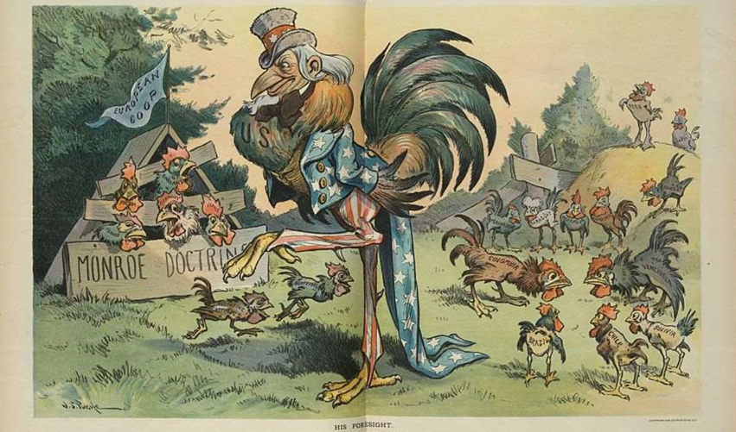
- Who does the large chicken represent? How do you know?
- What the chickens on the left represent? What do the chickens on the right represent?
- What is the significance of the large chicken standing in between the groups?
Purpose
Point of View
Meaning of the Cartoon

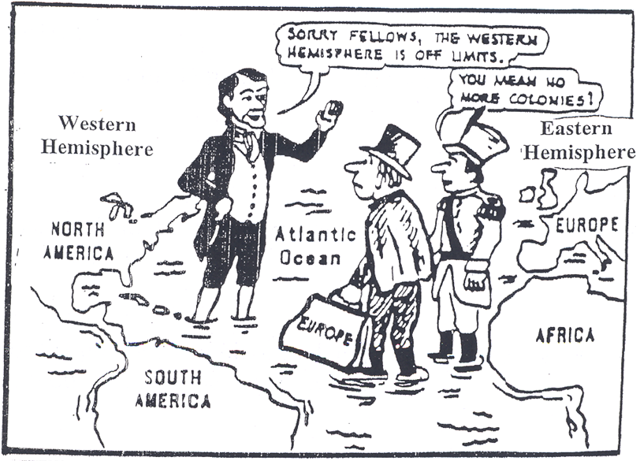
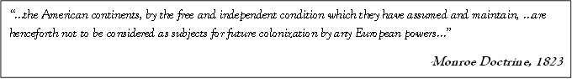
- Who is the man in the black suit? How do you know?
- Why are all the men in the cartoon standing in the Atlantic Ocean?
- According to the quote below the cartoon, what are the European powers prohibited to do in the American Continents?
Purpose
Point of View
Meaning of the Cartoon

