The New Deal Packet
Document A: FDR
President Franklin D. Roosevelt gave this speech on August 14, 1935 when he signed the Social Security Act.
Today a long-held hope is largely fulfilled. The civilization of the past 100 years, with its startling industrial changes, has made life insecure. Young people have come to wonder what would happen to them in old age. The man with a job has wondered how long the job would last.
This social security measure gives some protection to 30 million of our citizens who will receive direct benefits through unemployment compensation, through old-age pensions, and through increased services for the protection of children and the prevention of ill health.
We can never insure 100 percent of the population against 100 percent of the ups and downs of life, but we have tried to pass a law which will give some protection to the average citizen and to his family against the loss of a job and against poverty-ridden old age.
This law, too, represents a cornerstone in a structure intended to lessen the force of possible future depressions. It will act as a protection to future Administrations against the necessity of going deeply into debt to help the needy. It is, in short, a law that will take care of human needs and at the same time provide the United States a sound economic structure.
- Who gave this speech and when? Who is the intended audience? How might that influence the content and tone of the speech?
- What four programs are included in the Social Security bill? How does Social Security represent FDR’s program of “relief, recovery, and reform”? For each of the three words, write one quote or example that illustrates connections
Document B: NAACP
President Roosevelt sent his Social Security bill, named the “Economic Security Act,” to Congress in January 1935. Congress held committee hearings on the bill. Here, a representative of the National Association for the Advancement of Colored People (NAACP), a group dedicated to advancing the rights of African Americans, testified before Congress about how the bill excluded certain groups of people.
Mr. Houston: The point that I am making is that in order for a person to qualify for Social Security, taxes must be paid on behalf of this person before he turns 60.
Now, for the benefit of Negroes, I want to ask, who would be left out by that rule?
First, and very serious, Negro sharecroppers and cash tenants would be left out. We all know that the Negro sharecropper and the Negro cash farm tenant are at the bottom of the economic scale. He is not employed. There is no relation of master and servant by which he gets wages on which a tax could be collected. Therefore this population is left out from the old-age annuity, and that represents approximately 490,000 Negroes. Next, domestic servants are excluded from the act because the system of employing domestic servants is so loose.
In addition to that, this old-age annuity does not provide for unemployed persons. I do not need to argue to the committee that Negroes have suffered from unemployment more than any other class of the community .
- What four groups does Houston say are excluded from Social Security?
- What would NAACP representative Houston say about FDR’s speech (Document A)? Select a line from Document A: FDR and explain how Houston might disagree.
Document C: Stealing (Modified)
Americans sent thousands of letters to the White House during FDR’s presidency and many were addressed to Eleanor Roosevelt, the First Lady. On average, more than 5,000 letters arrived daily. This letter refers to the “forgotten man,” the title of a radio address that FDR gave on April 17, 1932. The “forgotten man” became a phrase adopted by many Americans.
no address
Jan 18, 1937
Dear Mrs. Roosevelt,
I was simply astounded to think that anyone could be nitwit enough to wish to be included in the so-called social security act if they could possibly avoid it. Call it by any name you wish, but it is, in my opinion (and that of many people I know), nothing but downright stealing.
Personally, I had my savings invested so that I would have enough money for old age. Now thanks to the President, I cannot be sure of anything, being a stockholder. After business has survived his merciless attacks (if it does), insurance will probably be no good either.
Believe me, the only thing we want from the president is for him to balance the budget and reduce taxes.
I am not an “economic royalist,” just an ordinary white-collar worker at $1600 per year. Please show this to the president and ask him to remember the wishes of the forgotten man, that is, the one who dared to vote against him. We expect to be tramped on but we do wish the stepping would be a little less hard.
Security at the price of freedom is never desired by intelligent people.
M.A. [female]
- What does the author tell us about herself? What kind of person do you think she is based on the information in this letter?
- What was M.A. counting on to support her in old age? And why has she lost faith that this will support her?
- How does this author generally feel about the New Deal? How does her phrase “security at the price of freedom” capture those feelings?
Historian Interpretation 1: Carl Degler | Historian Interpretation 2: Bart Bernstein
Historian Carl Degler argued that the New Deal was revolutionary. He believed that the New Deal represented a drastic change in how Americans viewed government and its role in the economy. Rather than expecting economic troubles to be solved by market forces (a faith in "laissez-faire economics"), Americans began to expect the government to act in times of economic trouble and intervene to help make things better.  Degler saw Social Security as a piece of this change, signaling that Americans viewed the government as responsible for ensuring that older Americans would live decent lives. This was a shift from thinking that this responsibility lay only with individuals and families. The American public was ready for a change after experiencing the severe conditions during the Great Depression, when banks were failing, industries were faltering, and people were unemployed. Degler argued that the New Deal constituted a permanent shift in the American public’s expectations: they now wanted the government to be an active player in the economy.  Carl N. Degler, "The Third American Revolution," in Out of Our Past: The Forces that Shaped Modern America,1959. | Historian Barton Bernstein, writing in the late 1960’s, argued that the New Deal was no revolution, and that the changes suggested by Degler and others had been exaggerated. The New Deal was a narrow program of limited reform that excluded millions of Americans. Bernstein saw the New Deal as fundamentally a conservative program partly motivated by a fear of more radical ideas (like those proposed by Huey Long).  Specifically, Bernstein saw the Social Security Act as more symbol than substance. Workers had to contribute to their old age pensions and could not depend on government contributions: thus, it was a limited kind of aid. More than one out of every five workers was excluded from the pension plan, including those who worked on farms and as domestic help, and this workforce was disproportionately black or female. Bernstein argued that while the New Deal reduced suffering, it did not deserve the praise for revolutionizing America that others lavished upon it.  Barton Bernstein, "The Conservative Achievements of Liberal Reform," in Towards a New Past, 1968.
Summarize Degler’s argument in your own words: | Summarize Bernstein’s argument in your own words:
- Using information from and all three documents, write one paragraph in response to the following question: Which historical account of Social Security is more accurate, Degler’s or Bernstein’s? (5-7 Sentences)
Agricultural Adjustment Act (1933, 1938)
Civil Works Administration (1933)
Civilian Conservation Corp (1933)
Emergency Banking Relief Act (1933)
Fair Labor Standards Act (1938)
Farm Security Administration (1937)
Federal Communications Act (1934)
Federal Emergency Relief Administration (1933 & 35)
Federal Securities Act (1933)
Glass-Steagall Banking Act (1933)
National Industrial Recovery Administration (1933)
National Labor Relations Act (1934)
Public Works Administration (1933)
Rural Electrification Act (1935)
Securities Exchange Act (1934)
Social Security Act (1935)
Tennessee Valley Authority (1933)
Works Progress Administration (1935)

Document 1: Step By Step Cartoon
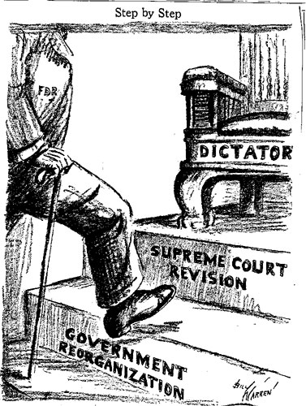

Analyze and evaluate President Roosevelt’s words, study the cartoon, and answer the following questions.
- What provisions for the Supreme Court are set by the U.S. Constitution? Read Article III of the Constitution to find out.
- How would Roosevelt’s plan change the Supreme Court?
- What was the reaction to Roosevelt’s plan, as displayed in the political cartoon?
- Why did the bill cause such a strong reaction?
- What specific objections did opponents of the plan have?

Document 2: “The Man of the Hour ” Fred O. Seibel Richmond Times Dispatch, 1933
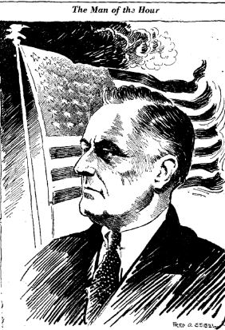
- How is FDR portrayed?
- What challenges does FDR face as he embarks on his new job as president?
- What objects are included in the cartoon, and what do they symbolize?
- What does, “man of the hour” mean?

Document 3: New Deal Evaluation
The New Deal: “I pledge you, I pledge myself, to a new deal for the American people.” –Acceptance speech at democratic Convention, 1932
The New Deal is the name given to the programs launched by President Franklin D. Roosevelt during 1933-1937, with the goal of RELIEF, RECOVERY, and REFORM to the national economy. During FDR’s first “100 Days” in office, he created many “alphabet agencies,” some set up by Congress, others by executive order, to help Americans during this difficult period. FDR told the American people at his inaugural: “This nation asks for action, & action now.”
Supporters Said …
- Brought economic recovery
- Prevented the economic and political collapse of the U.S.
- Created government jobs for unemployed
- Created programs to prevent future depressions
- Gave relief to the farmers
- Created jobs for young American
- Instilled more hope in the future
- Supported the work of artists
- Set a precedent for the federal government playing a key role in the economic and social policies of the nation
Critics thought that…
- The New Deal did not do enough for people
- Too expensive
- It was disorganized and the programs were not well thought out.
- It did not address African Americans’ troubles
- Tremendous cost would further bankrupt the country
- The Supreme Court and others felt it gave the president too much power. Some judges felt it was unconstitutional.
- It expanded the role of the federal government
Your Task: You need to write a one paragraph response arguing for or against the New Deal. One paragraph must address why your or in favor or a critic of the New Deal. The other paragraph must discredit the other side. Each paragraph must be at least eight (8) sentences.

